Multiple-choice section – choose the correct answer

Question 1 [2.3]

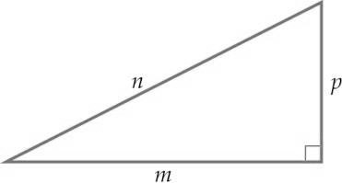

Which one is a true statement of Pythagoras’ theorem?

A *m*2 + *n*2 = *p*2 B *m*2 = *n*2 + *p*2  C  D *m*2 + *p*2 = *n*2

Question 2 [2.1]

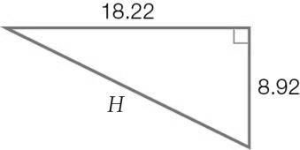

Which one of these equations could be used to find the length of the hypotenuse (*H*) in the right-angled triangle?

A *H*2 = 18.222 + 8.922 B *H*= 18.22 + 8.92 C *H*2 = 18.222 – 8.922 D *H* = 

Question 3 [2.5]

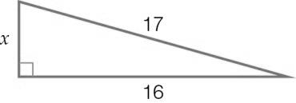

The hypotenuse of a right-angled triangle has a length of 17 units. The length of one of the shorter sides is 14 units. What is the exact value of the third side?

A  B  C  D 

Question 4 [2.2]

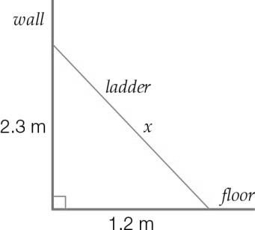

A ladder leans against a wall as shown in the diagram. Which one of the following statements is true?

A The ladder is 3.5 m long.

B The top of the ladder is 2.3 m from the wall.

C The bottom of the ladder is 2.3 m from the wall.

D The bottom of the ladder is 1.2 m from the wall.

Question 5 [2.4]

(5, 12, 13) is a Pythagorean triple.   
Which one of these sets of numbers is also a Pythagorean triple?

A (6, 13, 14) B (10, 24, 27) C (15, 36, 39) D (50, 110, 130)

Question 6 [2.2]

If *h*2 = 4.82 + 8.32, find the value of *h* to 2 decimal places.

A 9.58 B 9.59 C 91.93 D 45.97

Multiple-choice results: ___ / 6

Short answer section

Question 7 3 marks [2.1, 2.2]

The hypotenuse is the longest/shortest side of a right-angled triangle.  
The hypotenuse is beside/opposite the right angle in a right-angled triangle.  
To find the length of the hypotenuse, add/subtract the squares of the two shorter sides, then take the square root.

Question 8 2 marks [2.1]

Label the right angle and the hypotenuse in each right-angled triangle.

**(a) (b)**

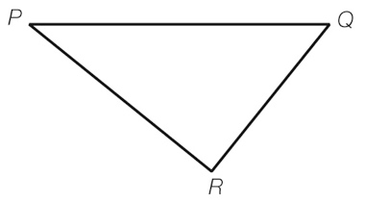 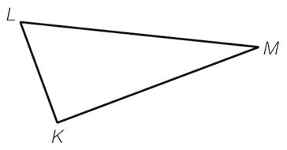

Question 9 1 mark [2.1]

Sketch a right-angled triangle with side lengths of 5 cm, 3 cm and 4 cm. Label the hypotenuse and the right angle.

Question 10 2 marks [2.2]

Adele wants to check that a room is ‘square’. She measures the length and width of the floor of the room as 3.1 m and 3.7 m and the diagonal across the room as 4.9 m.

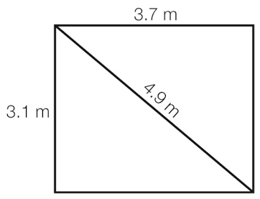

Use the converse of Pythagoras’ theorem to show that Adele’s room is not ‘square’.

Question 11 6 marks [2.4]

Draw a labelled diagram for each situation.

**(a)** In the PE storeroom,a javelin is leaning against the wall. The javelin is 2.4 metres long and its top point touches the wall 2.3 metres above the floor.

**(b)** A truck driver uses a ramp to load his truck. The top of the ramp must be 1 metre above the ground. The ramp is 1.7 metres long.

**(c)** The top of a slide in a playground is 1.5 metres above the ground. The slide covers a horizontal distance of 4.5 metres.

Question 12 3 marks [2.3]

Find the length of the hypotenuse *p* in this triangle, to 2 decimal places.

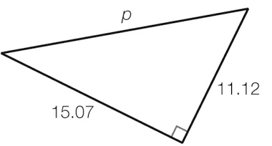

Question 13 2 marks [2.3]

Find the value of *a* in this right-angled triangle, to 2 decimal places.

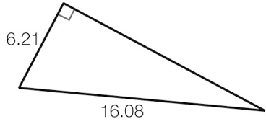

*a*

Question 14 2 marks [2.3]

Find the value of the pronumeral *x* in this right-angled triangle.   
Give your answer in exact (surd) form.

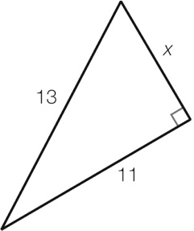

Question 15 3 marks [2.4]

Which one of these sets of numbers is a Pythagorean triple? (Show calculations for each set.)

Set 1: (32, 126, 130)

Set 2: (40, 42, 57)

Short answer results: ___ / 24

Extended answer section

Question 16 5 marks [2.1, 2.5]

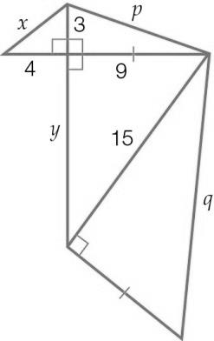

(a) Use Pythagorean triples to write the values of *x* and *y*.

(b) Write the equations you would use to find *p* and *q*. (Do not solve the equations.)

Question 17 5 marks [2.2, 2.4]

A flagpole is supported by two wires. The wires are 8.5 metres long. They are attached to the flagpole at a point 7.5 metres above the ground.

The wires are pegged to the ground. The pegs and the base of the flagpole are in a straight line.

(a) Find the distance between the base of the flagpole and one of the pegs.

(b) How far apart are the pegs?

(c) The pegs are moved closer to the flagpole. If the pegs are now 2 metres from the base of the flagpole and the wires are still joined to the pole at the same place, what is the total length of wire needed? (Give your answer in metres correct to 2 decimal places.)

Question 18 6 marks [2.3, 2.4]

Abdullah walks from the train station (point *A*) to his house (point *B*). In this diagram of his walk, the lines on the grid are spaced 100 m apart.

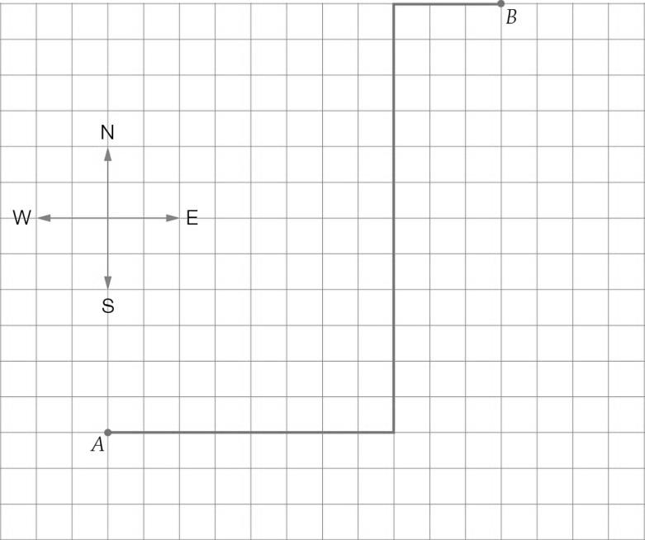

(a) Fill in the missing distances and directions in this description of Abdullah’s walk.

Abdullah walks ______ m east, then _____ m ____ and then 300 m ____.

(b) How many kilometres does Abdullah walk altogether?

(c) If Abdullah walks home from the train station in a straight line, how far does he have to walk? (If a straight line is drawn from point A to point B, what is the length of this line?) Give your answer rounded to the nearest metre.

Extended answer results: ___ / 16

TOTAL test results: ___ / 46